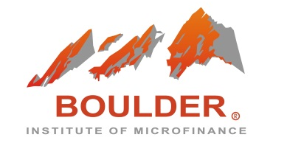

Tuition Discount Policy

Boulder Rural and Agricultural Finance Program

Boulder Institute of Microfinance (BI) is a purpose driven renowned institution with over 24 years of significant achievements in promoting sustainable access to finance by training microfinance professionals around the world. In the spirit of expanding BI’s scale of contribution to promoting financial inclusion, our institution offers generous tuition discounts to individual alumni and group participants attending the English Language Rural Agricultural Finance Program (RAFP) in 2018.

Qualifying participants meeting the following conditions will benefit from the allocated tuition discounts per the below chart:

Tuition Discount Category | Tuition Discount Rate
Alumni – returning BI participant | 10%
Three (3) to four (4) participants from a single organization | 7%
Five (5) to seven (7) participants from a single organization | 10%
Eight (8) to ten (10) participants from a single organization | One (1) full tuition waived!

The above discount categories are exclusive of each other. A participant benefiting from one discount category will not be eligible for another category of discount. For instance, an alumnus receiving a 10% tuition discount will not qualify for additional group discounts regardless of group association or organization.

If you have any questions or require further information, please contact RAFP Program Manager, Gabriela Christen-Munoz, at gabriela@bouldermicrofinance.org, or talk to one of our team members at pax_rafp@bouldermicrofinance.org.

