REGISTRATION FORM

Pls. check √ for attendance
- Regional Policy Forum (RPF) and Gala Dinner (Full Day: 9 February 2026)
- The 79th APRACA Executive Committee Meeting (EXCOM) (Morning Session: 10 February 2026):
- 24th General Assembly Meeting (GA) (Afternoon Session: 10 February 2026)
- Field visits (Full Day: 11 February 2026)

Please complete this form and e-mail to Bank for Agriculture and Agricultural Cooperatives at chatsiri.sr@baac.or.th
under copy to APRACA Secretariat at kittisak@apraca.org on or before 15 January 2026

1. PERSONAL DETAILS:
Name: |  |  |  |  |  | Position:
Organisation:
Address:
Tel: |  |  | Fax: |  | E-mail:
Invitation letter from Bank for Agriculture and Agricultural Cooperatives (BAAC) for visa application. |  |  |  |  | Yes
 |  |  |  |  | No

2. Passport Particulars: (Prepare separately for accompanying person(s)
Full Name: |  | Nationality:
Date of Birth: |  | Place of Birth:
Gender: |  | Passport No:
Place of Issue: |  | Date of Issue:
Date of Expiry: |  | Place to Apply for Visa:

3. ACCOMPANYING PERSON:
Name: …………………………………………………….. Relationship: …………………………………………………………………
4. ACCOMMODATION: Name of hotel/address (Pls. check √ for your intent)
Name of the Hotels | Room Type and Tariff
Hotel: Best Western Chatuchak, Bangkok  Address: 18 Kamphaeng Phet Road Chatuchak, Chatuchak, Bangkok, Thailand 10900  Mobile: +66 (0)2-666-4695  E-mail: info@bestwesternchatuchak.com  Website: https://www.bestwesternchatuchak.com/  Contact Person Name: Staff (To be informed later)  **This hotel is not the venue for meetings and other activities | Type 1: Superior Double Bedroom  (23 Sq.m.) 1,600 THB  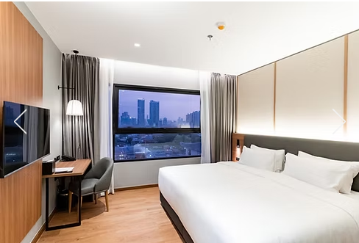  Type 2: Superior Twin Bedroom  - q.m.) 1,800 THB  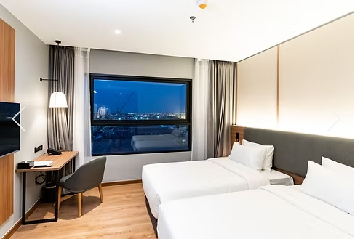  - The room rent includes breakfast

Name of the Hotels | Room Type and Tariff
Hotel: Centara Grand** at Central Plaza Ladprao Bangkok  Address: 1695 Phaholyothin Road, Ladprao Chatuchak, Bangkok, 10900, Thailand  Mobile: +66 (0)-2-541-1234 wan. 4421  E-mail: phanuwatla@chr.co.th  Website: https://www.centarahotelsresorts.com/  Contact Person Name: Staff (To be informed later  **This hotel is also the venue for meetings and other activities. | Type 1: Deluxe King Size Bedroom  (35 Sq.m.) 3,000 THB  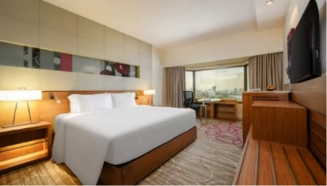  Type 2: Deluxe Twin Bedroom  (35 Sq.m.) 3,000 THB  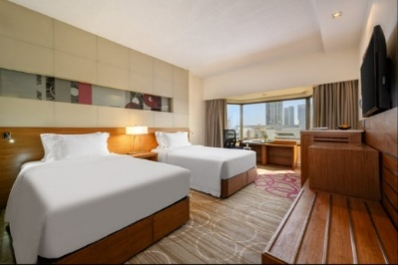  - The room rent includes breakfast

5. FLIGHT DETAILS:

Date | Flight No. | From | To | Dept. Time | Arr. Time
CHECK OUT ON:

6. Food preference (please check √ )
- Vegetarian | - No Pork | - No Beef | □ No Restrictions
- Others: Please specify

